Patient Info ¹ | Referring Doctor Info ^{1, 2}
Full name | Full name
Sex / Age | Specialty (Specialization)
Home address | Clinic address
Phone / Ε-mail | Phone / Ε-mail
Patient Evaluation Form

¹ Please send relevant medical examinations and diagnostic imaging.
² To be completed if referred by the Doctor. We will contact you as soon as possible after the examination - evaluation of the patient.
Medical History
(if existing disease please give details)
Cardiovascular | Endocrinopathies
Respiratory | Infectious diseases
Gastrointestinal | Autoimmune diseases
Hematopoietic | Other
Musculoskeletal | Smoking (cigarettes / day and duration)
Skin diseases | Alcohol (drinks / day and duration)
Psychiatric diseases | Medication
Diabetes mellitus
Allergies

Reason for Referral
(please give details)
Ulceration | Oral pigmented spots
White / Red lesions | Burning / Stinging
Xerostomia | Blister
Altered taste | Impacted / Semi – impacted 3rd molar
Oral soreness | Implant placement
Lump | Apicoectomy
Aphthae | Sinus lift
Oral malodor | Other
Duration of lesions / symptoms

Similar conditions in the past ?

Any treatments already applied for this reason ?

Have you seen any other Doctors for this problem ?

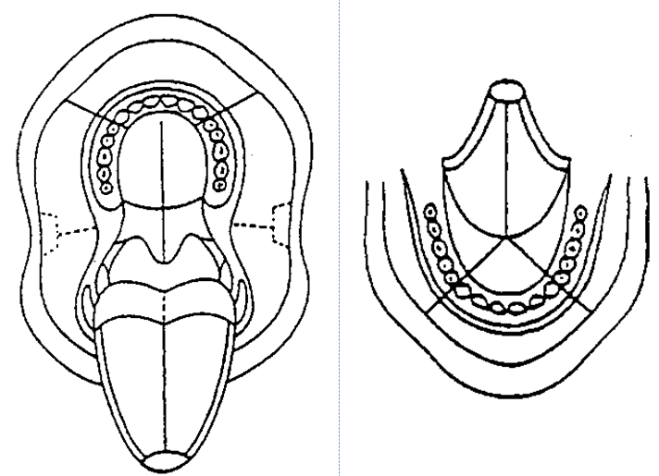

Mark the area of the lesion / symptoms in the diagram.

Date

Full name / Signature

Fill in the form and send it by e-mail to titsinidess@yahoo.com or as an accompaniment during the examination at the Clinic

